Daycare HR Management System

The purpose of the Daycare HR Management System is to securely, efficiently and accurately maintain and manage staff and children on a daily basis.

The system will be able to view or edit the photo Id of child educators, parent/parents or legal guardians and anyone else involved with caring for a child. Information of staff and children will be maintained up to date simply by accessing the system to edit any changes.

The system will provide child educators to write daily or weekly reviews for each child or group of children under their supervision and will be able to be seen by a parent(s) or legal guardian(s) and management. Also, management will be able to write daily or weekly reviews regarding child educators or any other personnel involved with the child.

List of additional technologies to be implemented:

* Google maps
* File storage in BLOBs
* Facebook login

List of URLs to be implemented:

* /register
* /login
* /recoverpassword
* /child/{add,list}
* /child/:childId/{edit,delete}
* /child/:childId/comment/{add,view}
* /educator/{add,list}
* /educator/:childId/{edit,delete}
* /group/{add,list}
* /group/:childId/{edit,delete}

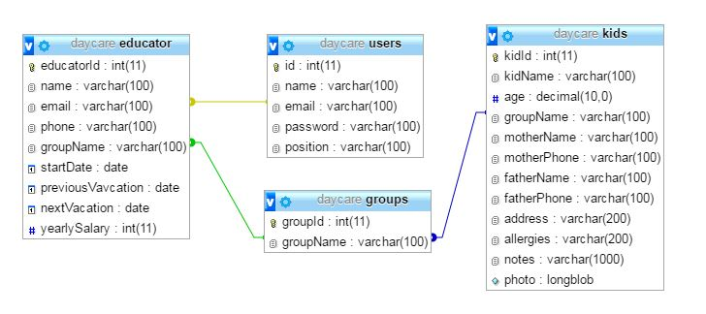

ddfhdf

D

Monitor

DAYCARE HR MANAGEMENT SYSTEM

Children List

DAYCARE HR MANAGEMENT SYSTEM